
FINAL CMCS POE
PROG6212
Jamie Simelane | 11/24/22 | ST10263509

Lecturer Feedback:
- Unit Tests should be created in a separate file
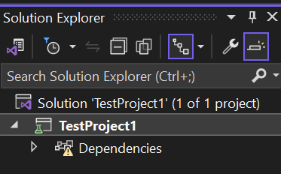
- Coordinators or Managers should give a reason why they are rejecting a claim
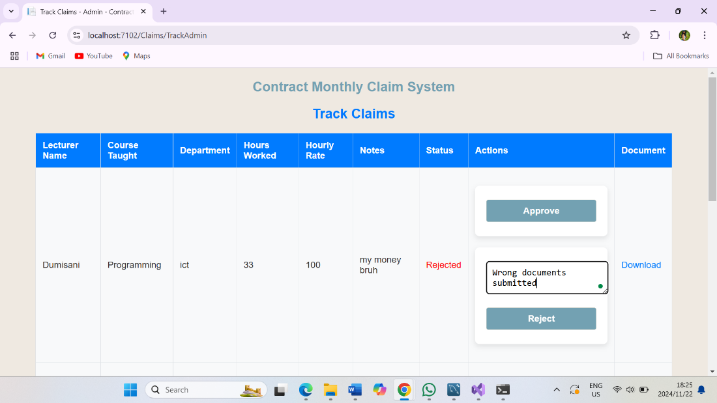
- Rejection reason should appear in all relevant pages
